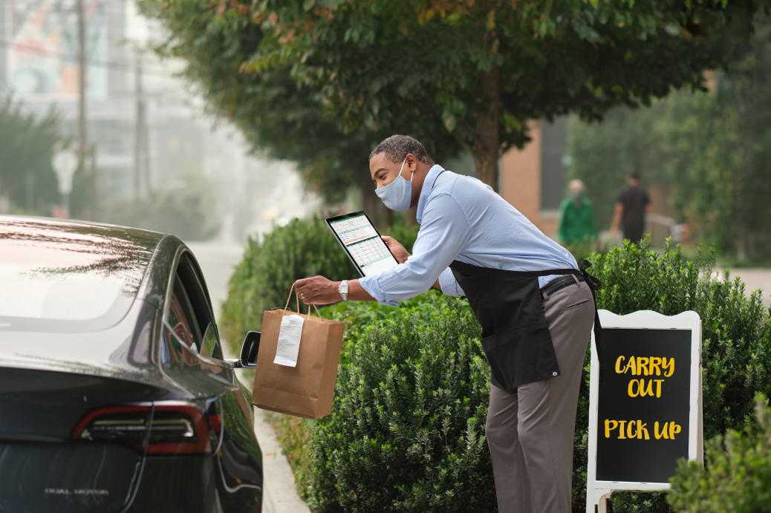
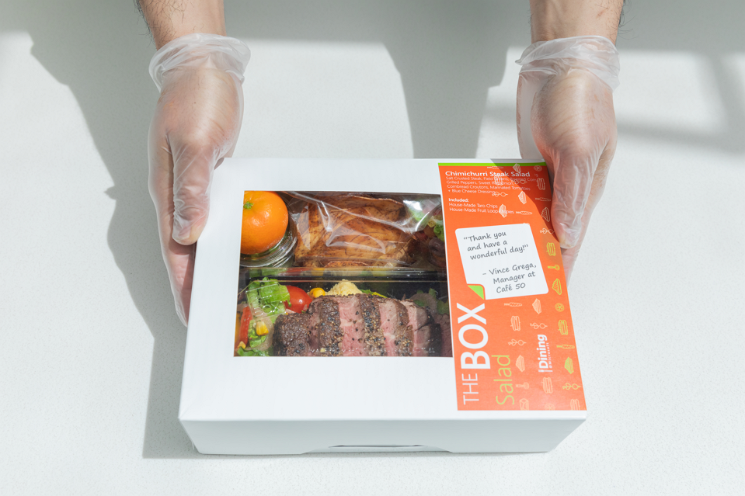

Review: Fourth Coffee has super options for food on the go. There is a big variety of boxed lunches that can be ordered in bulk as conference meals or purchased individually. My Mondays are always busy, and I like being able to get my meals to-go with them. I usually call ahead instead of trying to order online. The only issue is they run out of the most popular menu items quickly, so be sure to call ahead!
Date: October 8, 2018
Location: Seattle, Washington

